for all projects:

mvn clean

mvn install

mvn clean package docker:build

Discoveryservice

docker build -t discoveryservicedocker:1.0 .

docker run -d -p 8080:8080 -t discoveryservicedocker:1.0

docker tag acbc00918f82 priyasahu/discoveryservicedocker:1.0

docker push priyasahu/discoveryservicedocker:1.0

docker container run -d -it --name discoveryservicecontainer priyasahu/discoveryservicedocker:1.0 363352fc828c18788eb4eb598b67f410bc1460aa556125c7b4c3a467510e4347

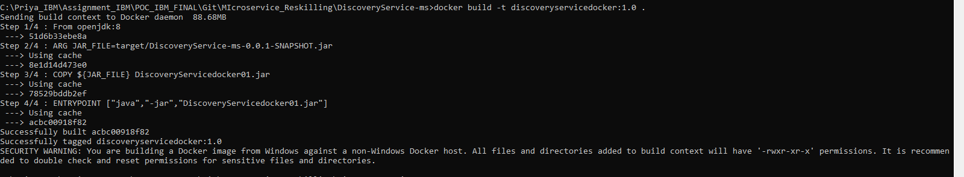



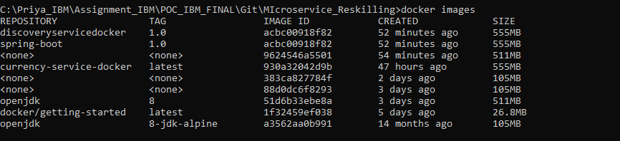



Currency Exchange service

docker build -t currenctservicedocker:1.0 .

docker run -d -p 8080:8080 -t currenctservicedocker:1.0

docker tag 973c56077017 priyasahu/currenctservicedocker:1.0

docker push priyasahu/currenctservicedocker:1.0

Currency Conversion service

docker build -t currencyconservicedocker:1.0 .

docker run -d -p 8080:8080 -t currencyconservicedocker:1.0

docker tag 224b8bc1f251 priyasahu/currencyconservicedocker:1.0

docker push priyasahu/currencyconservicedocker:1.0

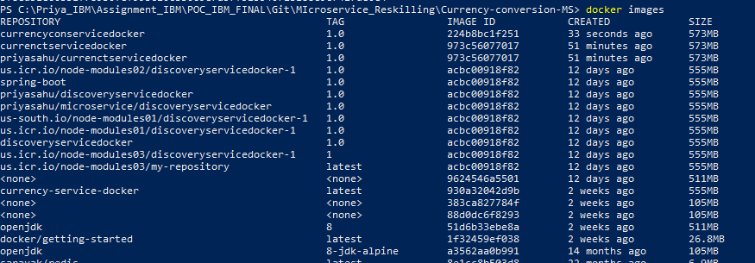

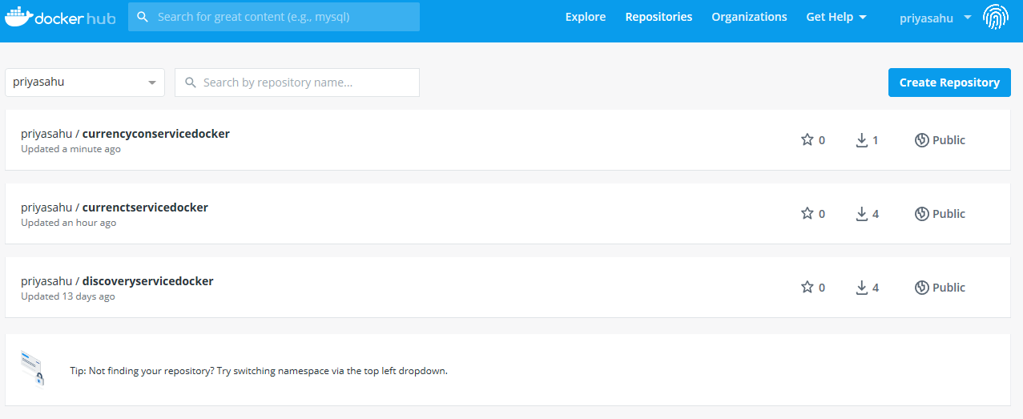

IBM Cloud

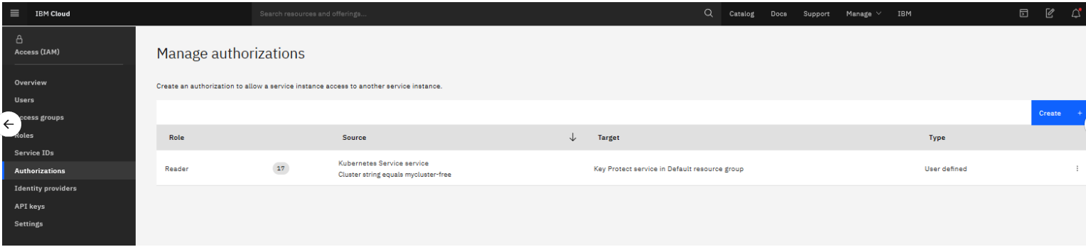

docker tag priyasahu/discoveryservicedocker:1.0 us.icr.io/node-modules03/discoveryservicedocker:1.0

docker push us.icr.io/node-modules03/discoveryservicedocker:1.0

docker tag priyasahu/currenctservicedocker:1.0 us.icr.io/node-modules03/ currenctservicedocker:1.0

docker push us.icr.io/node-modules03/currenctservicedocker:1.0

docker tag priyasahu/currencyconservicedocker:1.0 us.icr.io/node-modules03/ currencyconservicedocker:1.0

docker push us.icr.io/node-modules03/currencyconservicedocker:1.0

